Santander Holdings USA, Inc.



capital plan: Scenarios

**Table of Contents**

1 Scenarios 3

1.1 BHC Stress Scenario 3

1.2 FRB Severely Adverse Scenario 4

1.3 FRB Adverse Scenario 4

1.4 FRB Baseline Scenario 4

# Scenarios

In this section, SHUSA provides an overview of the four scenarios that it used to forecast its pro forma financials as part of the 2016 CCAR/DFAST exercise: (1) BHC stress scenario; (2) FRB severely adverse; (3) FRB adverse scenario; and (4) FRB baseline scenario. In Exhibit 1, SHUSA provides a consolidated overview of the four scenarios, including a comparison across four key variables.

Exhibit 1: Consolidated Overview of CCAR/DFAST Scenarios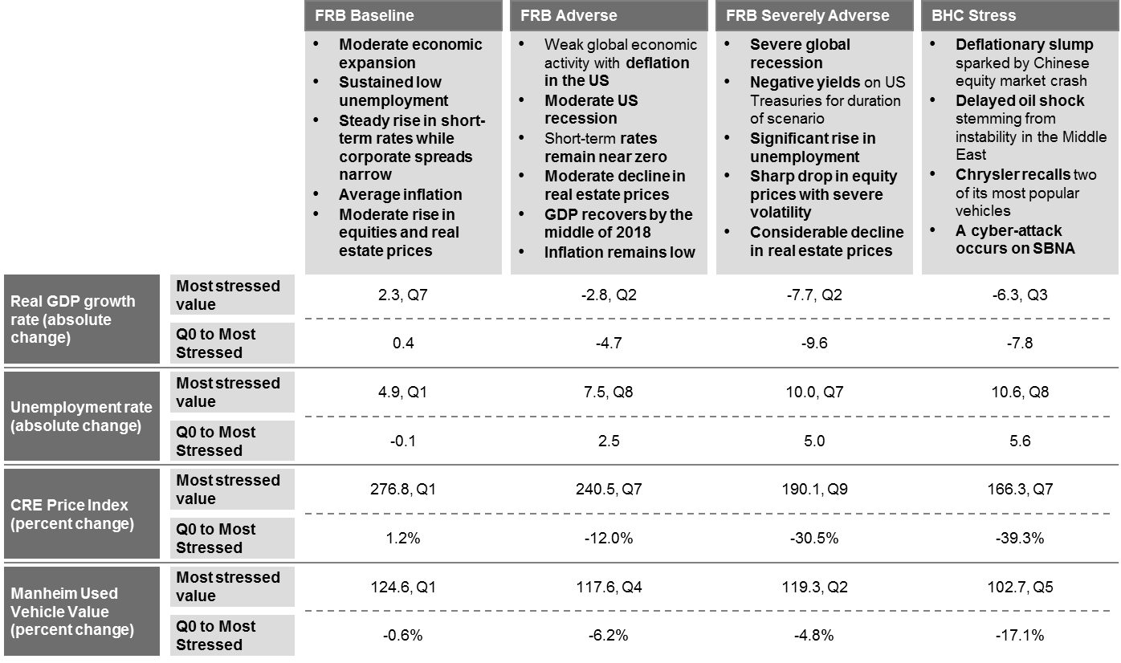

In the following sub-sections, SHUSA provides a summary of each scenario. For more details on the scenarios, including a description of the Scenario Generation process, supporting analysis, and the complete BHC stress narrative, see: XXX.

## BHC Stress Scenario

SHUSA’s stress scenario is triggered by a Chinese equity market crash, which leads the U.S. economy into a deflationary slump. The conditions worsen when instability in the Middle East causes a delayed oil shock. As a result, the unemployment rate increases significantly and the value of commercial and residential real estate declines. Short-term interest rates remain near zero and long-term bond spreads narrow. Deflation, malaise, and high fuel prices decrease demand for both new and older vehicles.

As part of its stress scenario, SHUSA also experiences two idiosyncratic events. After discovering a severe manufacturing issue, Fiat Chrysler enacts a massive recall, which negatively impacts SC’s auto lending business. Also, a cyber-attack on SBNA results in widespread loss and exposure of critical customer data.

Based on its analysis, SHUSA believes that this scenario stresses its most material risks at a sufficient level of severity. The CMG developed the BHC stress scenario around 15 variables that were identified during the risk identification process and reflect the core drivers SHUSA’s most material risks. During the scenario design process, the CMG ensured that the scenario sufficiently stressed these variables and addressed SHUSA’s greatest macroeconomic vulnerabilities. The CMG also calibrated the scenario severity by comparing the variable paths in the stress scenario to those in the FRB severely adverse scenario. Prior to use, the stress scenario was reviewed and challenged by the Capital Committee and the Board Risk Committee. The Board Risk Committee approved the BHC stress scenario on February XX, 2016 at a dedicated meeting held specifically for this purpose.

## FRB Severely Adverse Scenario

In the FRB supervisory severely adverse scenario, there is a severe global recession, accompanied by a period of heightened corporate financial stress and negative short-term U.S. treasury yields. The U.S. economy experiences a significant rise in unemployment, a considerable decline in real estate values, and a sharp drop in equity prices. The United Kingdom, euro area, and Japan all experience severe recessions and developing Asian countries experience mild recessions. As a result, the U.S. dollar depreciates modestly against the yen and appreciates against the euro, pound sterling, and currencies of developing Asian countries.

## FRB Adverse Scenario

The FRB adverse scenario includes weak global economic activity, accompanied by deflation in the U.S. and other countries. Amidst this recession, the U.S. unemployment rate rises steadily while consumer prices, equity prices, and real estate values decline moderately. Throughout 2018, the GDP recovers and inflation is minimal. As a result of the recession abroad, the dollar appreciates relative to foreign currencies, including the euro and those of developing Asian countries.

## FRB Baseline Scenario

The U.S. undergoes moderate economic expansion in the FRB baseline scenario. During this expansion, the unemployment rate remains low and there is average inflation. Treasury yields rise steadily and corporate spreads narrow modestly. There is a moderate rise in equity prices and real estate values. The United Kingdom, euro area, and Japan all experience modest real GDP growth and developing Asian countries experience strong GDP growth.

SHUSA’s view of the economy over the forecast horizon does not differ significantly from that provided in the FRB baseline scenario. For this reason, SHUSA utilized the FRB baseline scenario as its BHC baseline scenario, a decision permitted by regulatory guidance. The CMG supported this decision with analysis that benchmarked key variable indicators across SHUSA’s 2015 economic forecasts and the FRB’s 2015 economic forecasts. This analysis confirmed that the two forecasts are directionally consistent with negligible differences in magnitude. The Board Risk Committee reviewed, challenged, and approved this decision on February XX, 2016.